SETS AND FUNCTIONS jasveena-224001588
- sets are collection of objects : here objects can be anything.
For example, in a set of numbers the elements will be numbers, in a set of words the elements can be other related words or even alphabets.
- Functions : it is a way to manipulate or identify objects from sets, functions in sets are related to functions in programming somewhat. Functions help to identify what kind of a relation a particular function represents.

HOW TO DEFINE SETS ?
The objects in a set are called elements.
- A set is denoted using the curly braces {}
- ∈ denotes “belongs to”
- ∉ denotes “doesn’t belong to”
- the uppercase letters denote the sets and the lowercase letters denote the elements in the sets.
For Example :
A= set of numbers <5
A = { 4,3,2,1}
B = {x ∈ ℕ ∶ x < 4}
B= {1,2,3}

There are some commonly used number sets which we denote by specific letters, for example,

- ℕ The set of natural numbers: {1, 2, 3, 4, …}
- ℤ The set of integers: {0, ±1, ±2, …}
- ℚ The set of rational numbers: a/b, for a, b integers, b ≠ 0
- ℝ The set of real numbers, which includes ℕ , ℤ , ℚ , and irrational numbers
- ℂ The set of complex numbers: x + iy, for x, y real, i ² = −1
The universal set is denoted by U, whereas a null set is denoted by { } or ∅ .

SUBSETS AND PROPER SUBSETS
- A is called a subset of B if all the elements of A are there in B. it is denoted by A ⊂ B
- For Example : A = {1, 2, 3, 4 ,5 }
B = { 1,2,3,4,5,6,7,8,9} so A is a subset of B.
- We use A ⊄ B to denote that A is not a subset of B.

OPERATIONS ON SETS
UNION OF SETS
A union of set is nothing but combining all the elements of the given sets.
It is denoted by A ∪ B.
For example A={1,2,3,4,5,6}
B= { 7,8,9}
so A U B = { 1,2,3,4,5,6,7,8,9}

INTERSECTION OF SETS
Intersection means finding the common elements of the two sets and creating a new set.
For example :
A= {1,2,3,4,5,6}
B= {2,3,4,5,6,7,8,9}
A ∩ B = { 2,3,4,5,6}

COMPLEMENT OF SETS
Complement of a set is the set of all elements a universal set U, but not in A, and is denoted by Ā or A′
OR
The complement of a set is the set that includes all the elements of the universal set that are not present in the given set.

DIFFERENCE OF SETS
The set difference of A and B is the set of all elements in A excluding those in B, and is denoted by A\B or A − B.

LAWS IN SETS

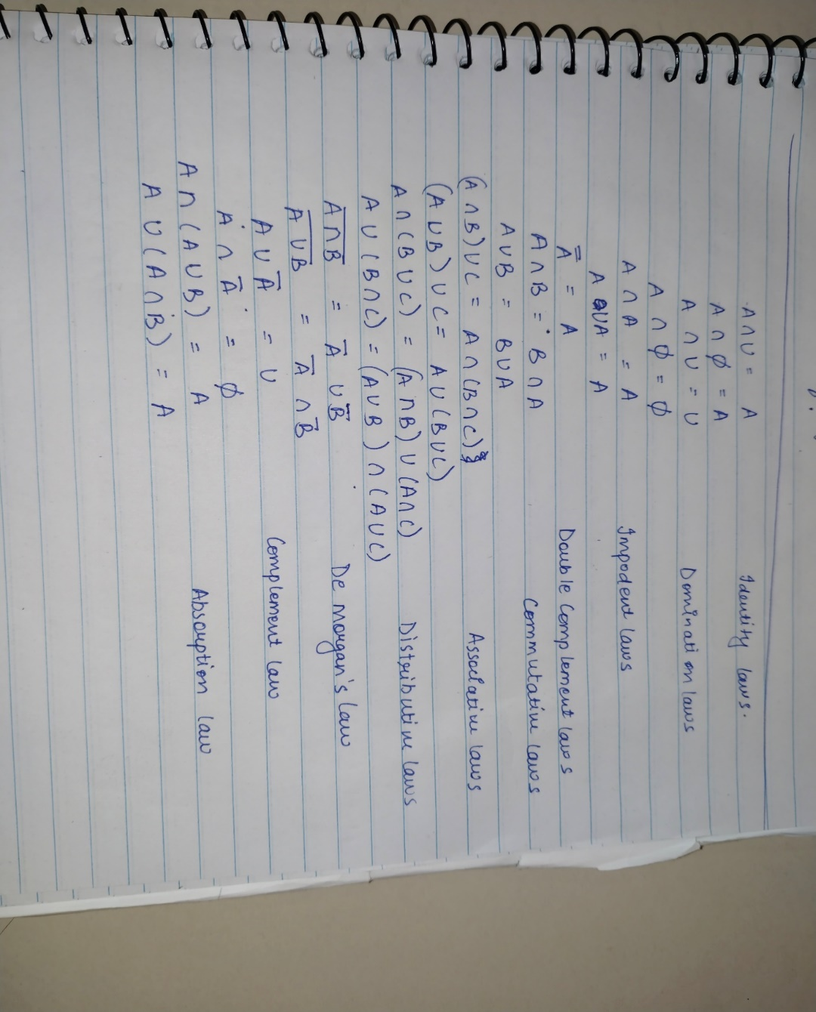

FUNCTIONS
An easy definition of what a function is, could be “functions are the expressions, rules or laws that define a relationship between one variable and the other.”
Functions are also called mappings or transformations.
For example :
- Let X and Y be sets. A function f from X to Y assigns each element of X to exactly one element in Y.
- In f ∶ X → Y, (i.e. f maps X to Y):
X is called the domain of f.
Y is called the co-domain of f.
- f (x) = y:
y is referred to as the image of x.
x is the pre-image of y.

EXAMPLES OF FUNCTIONS :
- f ∶ ℝ → ℝ ∶ f (x) = x²
- f ∶ ℝ → ℝ : f(x) = y = x (identity function)
- f ∶ ℝ → ℝ ∶ f(x) = y = c (constant function)
- f ∶ ℝ → ℝ ∶ f(x) = |x| (modulus function)
- f ∶ ℝ → ℝ ∶ f(x) = [x] (greatest integer function)
some more examples of functions include;

Floor function
The floor function takes an input x and outputs the greatest integer less than or equal to x.
For example f(5.5)= [5.5]= 5
Ceiling function
The ceiling function takes an input x and outputs the smallest integer greater than or equal to x.
For example f (5.5)= [5.5] = 6

INJECTIVE FUNCTIONS
A function is called an injective function when all the elements in the codomain have at most one pre image in the domain.
SURJECTIVE FUNCTIONS
A function is called a surjective function when all the elements in the codomain have atleast one pre image in the domain.
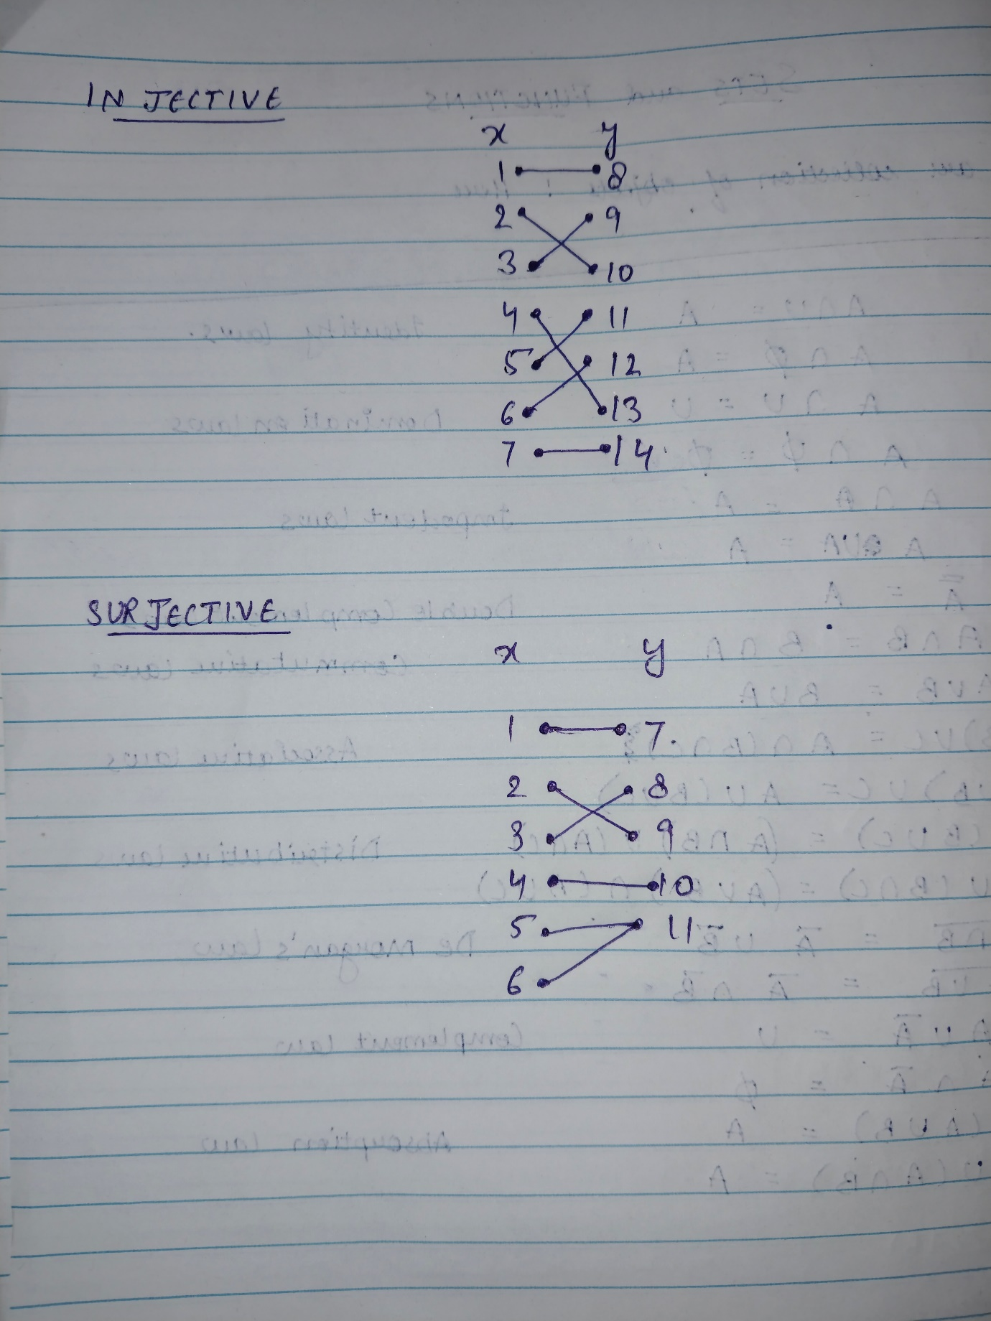
REFLECTIONS

WHAT IS THE MOST IMPORTANT THING YOU LEARNED FROM THIS MODULE ?
The most important thing I learned from this module was the operation with sets.
HOW IS THIS USEFUL ?
It is useful as it kind of makes segregating the data quite easily.
HOW DOES THIS RELATE TO WHAT YOU ALREADY KNOW ?
This whole task was based on sets and functions and except for one or two new concepts I was already familiar with everything as I studied it in school.
Why do you think your course teams wants you to learn the content of this module ?
I think this module is the basis of discrete mathematics and since this topic works with data. It will be quite useful in future.

